Hymn
Forsaken
Piano Sheet Music / Guitar Sheet Music
聖歌
遗弃
鋼琴樂譜 / 簡譜 / 吉他樂譜

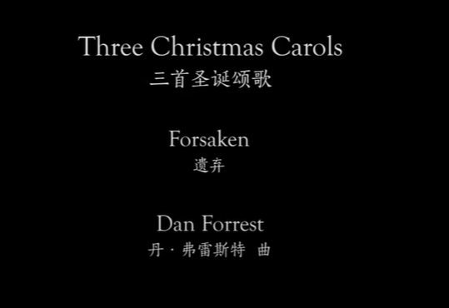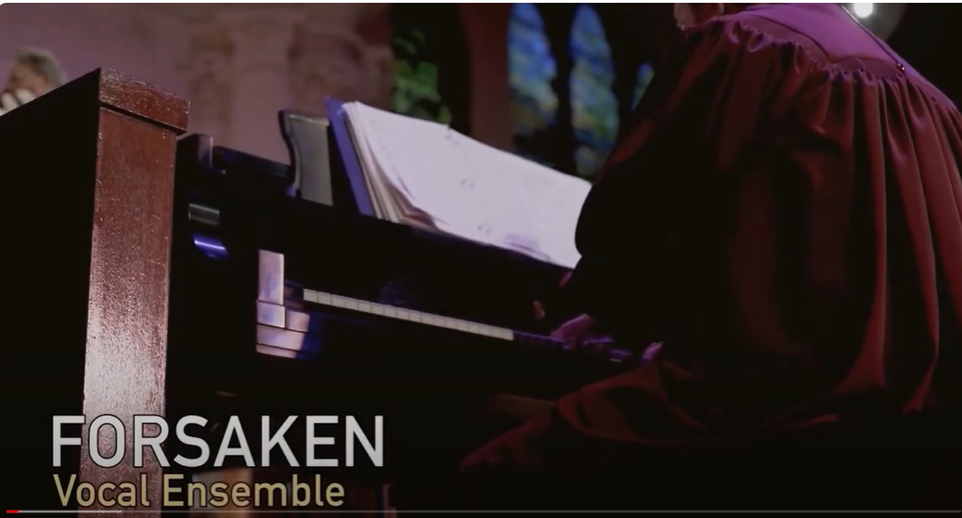

風火網頁 Webpage: https://www.feng-huo.ch/
Date: April 16, 2024
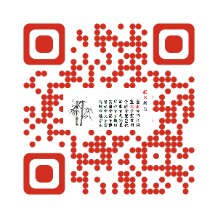

October 02, 2014

Aforthcoming choral anthem published by Beckenhorst Press features my lyrics and music by Dan Forrest. Dan wrote some sobering but powerful music that completely captures the grief Christ's sacrifice expressed in the text.
The text is written in a 1st-person narrative by Christ in the garden of Gethsemene and on the cross at Golgotha.

Forsaken—with Dan Forrest

“How long, My God, will You neglect My prayer?
Will You forget these tears of dark despair?
Yet not My will, but Yours alone be done:
Forsake not man, but Me—Your sinless Son.
I, Christ the Son, obey Your great command,
Enduring punishment for sinful man.
As Son and silent Lamb, I choose this path:
Accept rejection to appease Your wrath.”

“O why, My God, have You forsaken Me?
Why have You now refused My final plea?
Though I cry out in sorrow, pain, and fear,
You turn Your back; in silence, disappear.
I, Christ the Son, bear all their sin alone,
Embracing judgment from Your glorious throne.
As Son and spotless Lamb, I shed My blood
To bring them boldly to Your face, My God.”
It is available Fall 2014 from Beckenhorst Press for SATB choir, piano, and optional violin and cello.

VIDEO / Youtube
Maundy Thursday First Methodist Houston 2021: Forsaken -Dan Forrest (youtube.com)

https://www.youtube.com/watch?v=nvMY45GRX8I

5 2 Dan Forrest Forsaken (youtube.com) - Chinese

https://www.youtube.com/watch?v=PDaBsHFwZ-w - Chinese

