Hymn
Submission
Piano Sheet Music / Guitar Sheet Music
聖歌
順服
鋼琴樂譜 / 簡譜 / 吉他樂譜

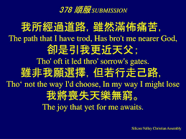

風火網頁 Webpage: https://www.feng-huo.ch/
Date: October 18, 2021
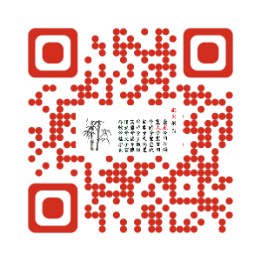

顺服

1 我所经过道路，虽然满布痛苦，
却是引我更近天父；
虽非我愿选择，但若行走己路，
我将丧失天乐无穷。

(副) 非我愿作何事，
非我愿去何地，
我是何人，竟敢选择己路！
救主为我拣选，
这是好得无比，
去留只愿遵主命令。

2 若只为得冠冕，使我去负十架，
十架就失该有价值；
既为主所颁赐，我就背负无惧，
负架原因只为我主。

3 惟我顺服神旨，主爱必然充溢，
一路既由?手引领；
主将我心高举，远超所居之世，
顺服，立见完全得胜。

顺服

一 我所经过道路，虽然满布痛苦，
却是引我更近天父；
虽非我愿选择，但若行走己路，
我将丧失天乐无穷。

(副)非我愿作何事，非我愿去何地，
我是何人，竟敢选择己路！
救主为我拣选，这是好得无比，
去留祇愿遵主命令。

二 若只为得冠冕，使我去负十架，
十架就失该有价值；
既为主所颁赐，我就背负无惧，
负架原因只为我主。

三 惟我顺服神旨，主爱必然充溢，
一路既由祂手引领；
主将我心高举，远超所居之世，
顺服，立见完全得胜。
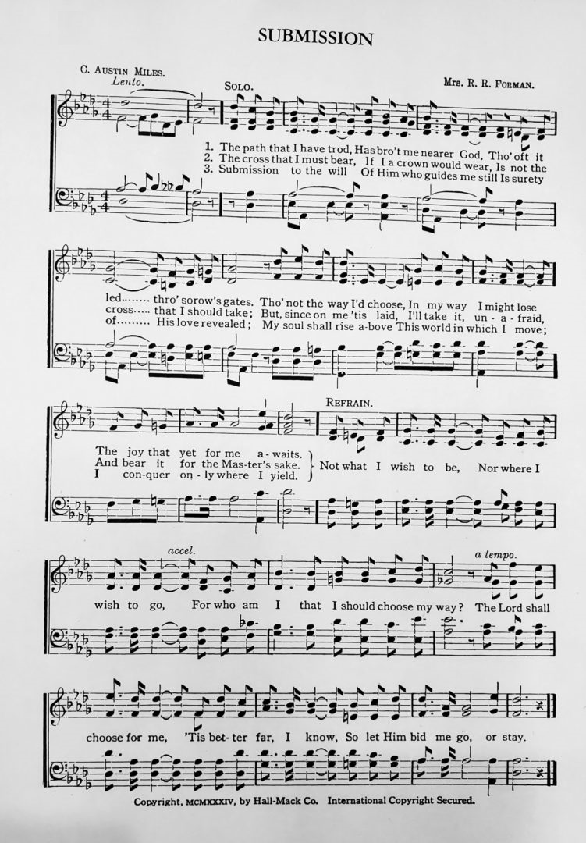

Submission

1. The path that I have trod,
Has brought me nearer God,
Though oft it led through sorrow's gates .
Though not the way I choose,
In my way I might lose
The joy that yet for me awaits
[Chorus]
Not what I wish to be,
Nor where I wish to go,
For who am I that I should choose my way?
The Lord shall choose for me,
'Tis better far, I know,
So let him bid me go, or stay

2. The cross that I must bear,
If I a crown would wear,
Is not the cross that I should take;
But since on me 'tis laid,
I'll take it unafraid,
And bear it for the Master's sake.
[Chorus]
Not what I wish to be,
Nor where I wish to go,
For who am I that I should choose my way?
The Lord shall choose for me,
'Tis better far, I know,
So let him bid me go, or stay

3. Submission to the will
Of him who guides me still
Is surety of His love revealed;
My soul shall rise above
This world in which I move,
I conquer only when I yield.
[Chorus]
Not what I wish to be,
Nor where I wish to go,
For who am I that I should choose my way?
The Lord shall choose for me,
'Tis better far, I know,
So let him bid me go, or stay

