Hymn
One with Thee, Thou Son Eternal
Piano Sheet Music / Guitar Sheet Music
聖歌
与你合一
鋼琴樂譜 / 簡譜 / 吉他樂譜

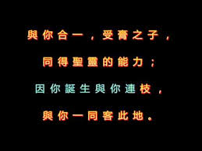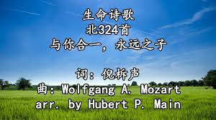

風火網頁 Webpage: https://www.feng-huo.ch/
Date: October 10, 2021

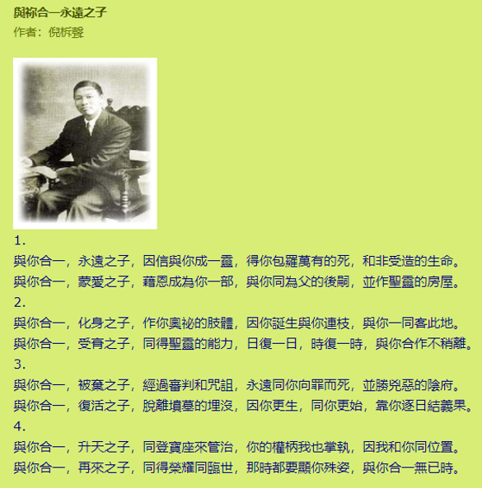

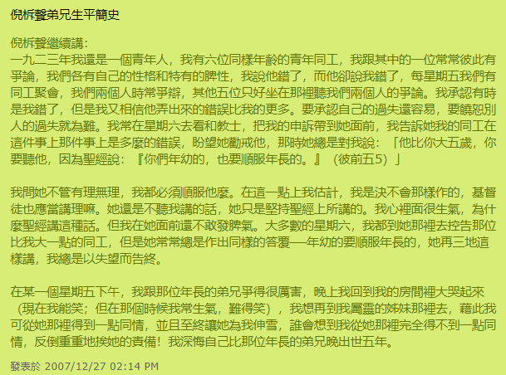
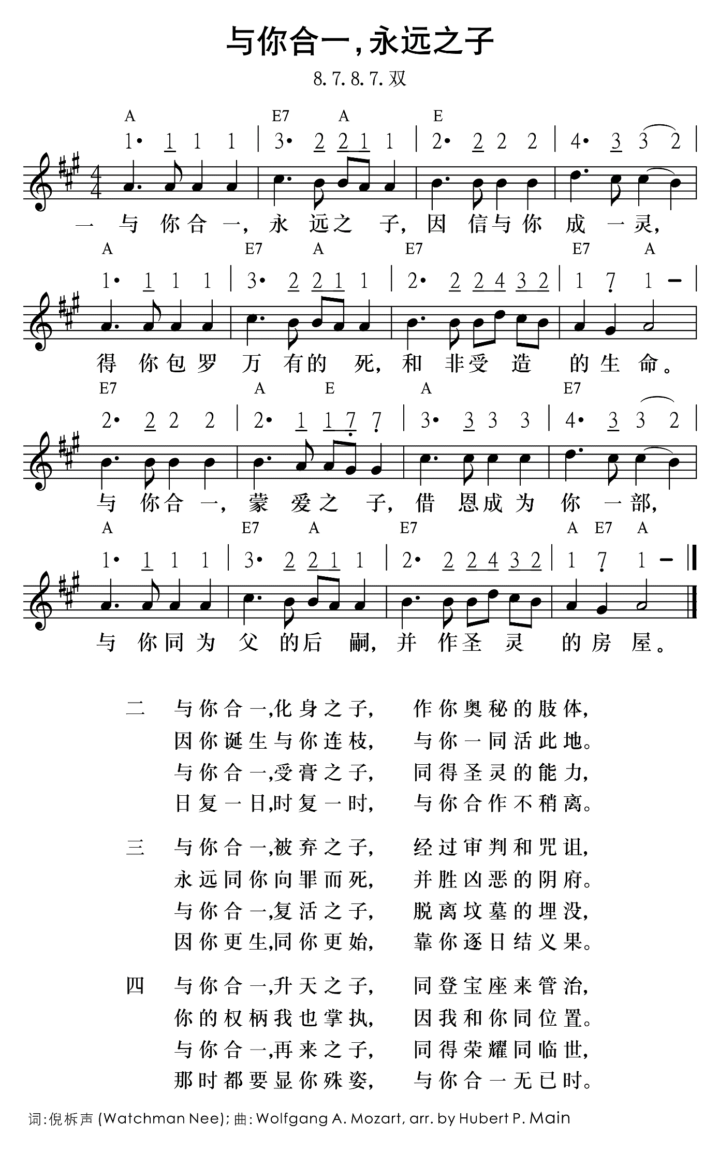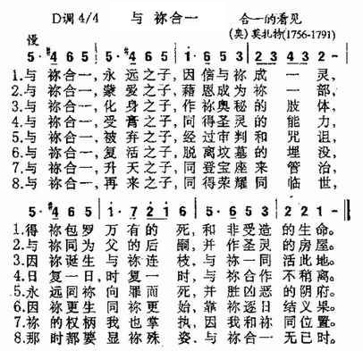

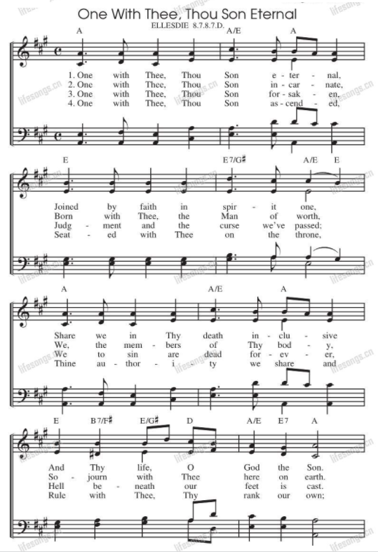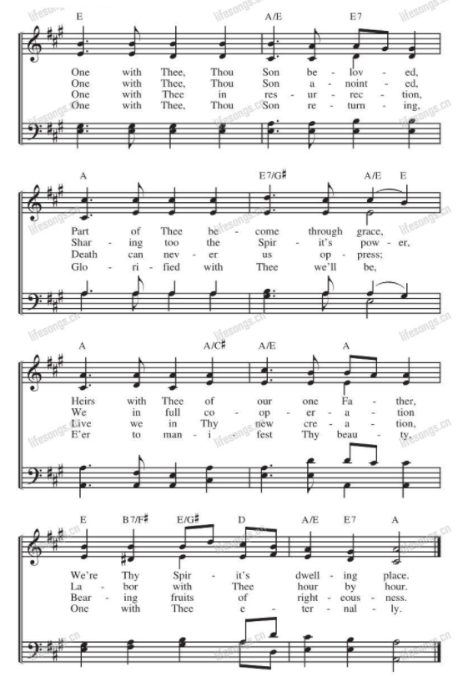
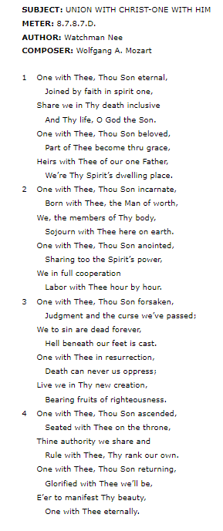
SUBJECT: UNION WITH CHRIST-ONE WITH HIM
METER: 8.7.8.7.D.
AUTHOR: Watchman Nee
COMPOSER: Wolfgang A. Mozart

1 | One with Thee, Thou Son eternal,
 |  | Joined by faith in spirit one,
 | Share we in Thy death inclusive
 |  | And Thy life, O God the Son.
 | One with Thee, Thou Son beloved,
 |  | Part of Thee become thru grace,
 | Heirs with Thee of our one Father,
 |  | We’re Thy Spirit’s dwelling place.
2 | One with Thee, Thou Son incarnate,
 |  | Born with Thee, the Man of worth,
 | We, the members of Thy body,
 |  | Sojourn with Thee here on earth.
 | One with Thee, Thou Son anointed,
 |  | Sharing too the Spirit’s power,
 | We in full cooperation
 |  | Labor with Thee hour by hour.
3 | One with Thee, Thou Son forsaken,
 |  | Judgment and the curse we’ve passed;
 | We to sin are dead forever,
 |  | Hell beneath our feet is cast.
 | One with Thee in resurrection,
 |  | Death can never us oppress;
 | Live we in Thy new creation,
 |  | Bearing fruits of righteousness.
4 | One with Thee, Thou Son ascended,
 |  | Seated with Thee on the throne,
 | Thine authority we share and
 |  | Rule with Thee, Thy rank our own.
 | One with Thee, Thou Son returning,
 |  | Glorified with Thee we’ll be,
 | E’er to manifest Thy beauty,
 |  | One with Thee eternally.

