Hymn
Stepping in the light
Piano Sheet Music
Guitar Sheet Music
聖歌
行在光明中
鋼琴樂譜
簡譜
吉他樂譜
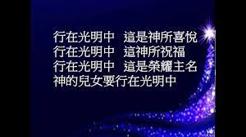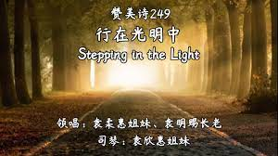

風火網頁 Webpage: https://www.feng-huo.ch/
Date: September 29, 2021
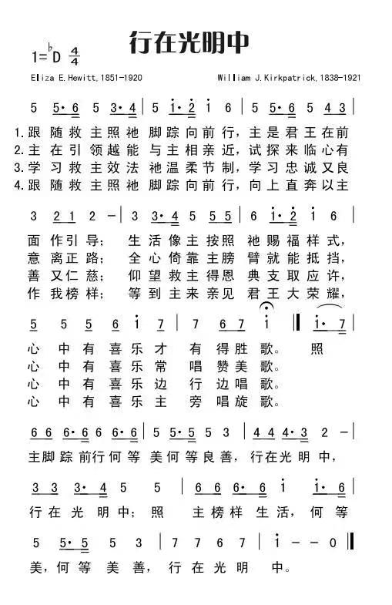
行在光明中 Stepping in the Light
1跟随救主照他脚踪向前行
主是君王在前途作引导
生活像主按照他赐福样式
心中有喜乐才有得胜歌
副歌 Chorus:
*照主脚踪前行 何等美 何等良善
行在光明中 行在光明中
照主榜样生活 何等美 何等美善
行在光明中
2主在引领越能与主相亲近
试探来临心有意离正路
全心倚靠主膀臂就能抵挡
心中有喜乐常唱赞美歌
3学习救主效法他温柔节制
学习忠诚又良善又仁慈
仰望救主得恩典支取应许
心中有喜乐边行边唱歌
4跟随救主照他脚踪向前行
向上直奔以主作我榜样
等到主来亲见君王大荣耀
心中有喜乐主旁唱凯歌
1 Trying to walk in the steps of the Savior
Trying to follow our Savior and King
Shaping our lives by His blessed example
Happy how happy the songs that we bring
* How beautiful to walk in the steps of the Savior
Stepping in the light Stepping in the light
How beautiful to walk in the steps of the Savior
Led in paths of light
2 Pressing more closely to Him who is leading
When we are tempted to turn from the way
Trusting the arm that is strong to defend us
Happy how happy our praises each day
3 Walking in footsteps of gentle forbearance
Footsteps of faithfulness mercy and love
Looking to Him for the grace freely promised
Happy how happy our journey above
4 Trying to walk in the steps of the Savior
Upward still upward we’ll follow our Guide
When we shall see Him the King in His beauty
Happy how happy our place at His side
