聖詩 / Hymn

我寧願有耶穌
I'd Rather Have Jesus

風火網頁: https://www.feng-huo.ch/
日期: February 16, 2018

我宁愿有耶稣简谱(降D調)

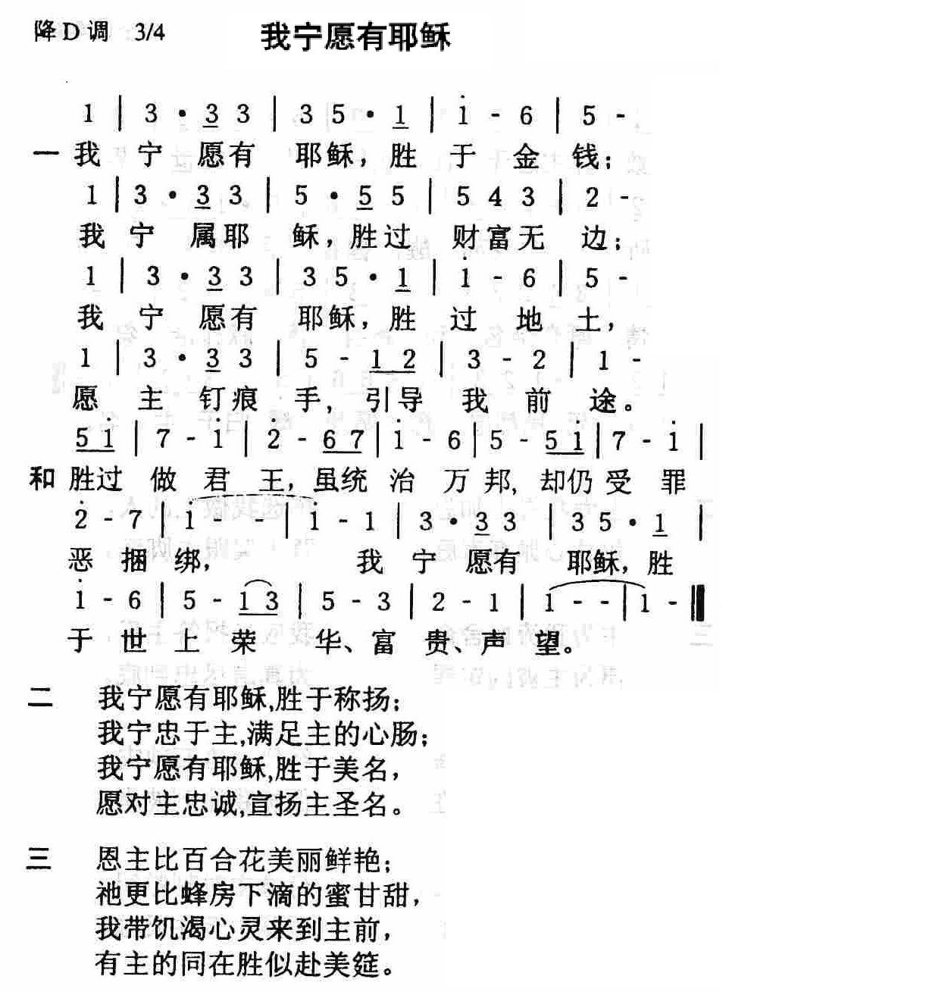

我宁愿有耶稣吉他谱(C大調)
I'd Rather Have Jesus sheet music for Guitar (C Major)
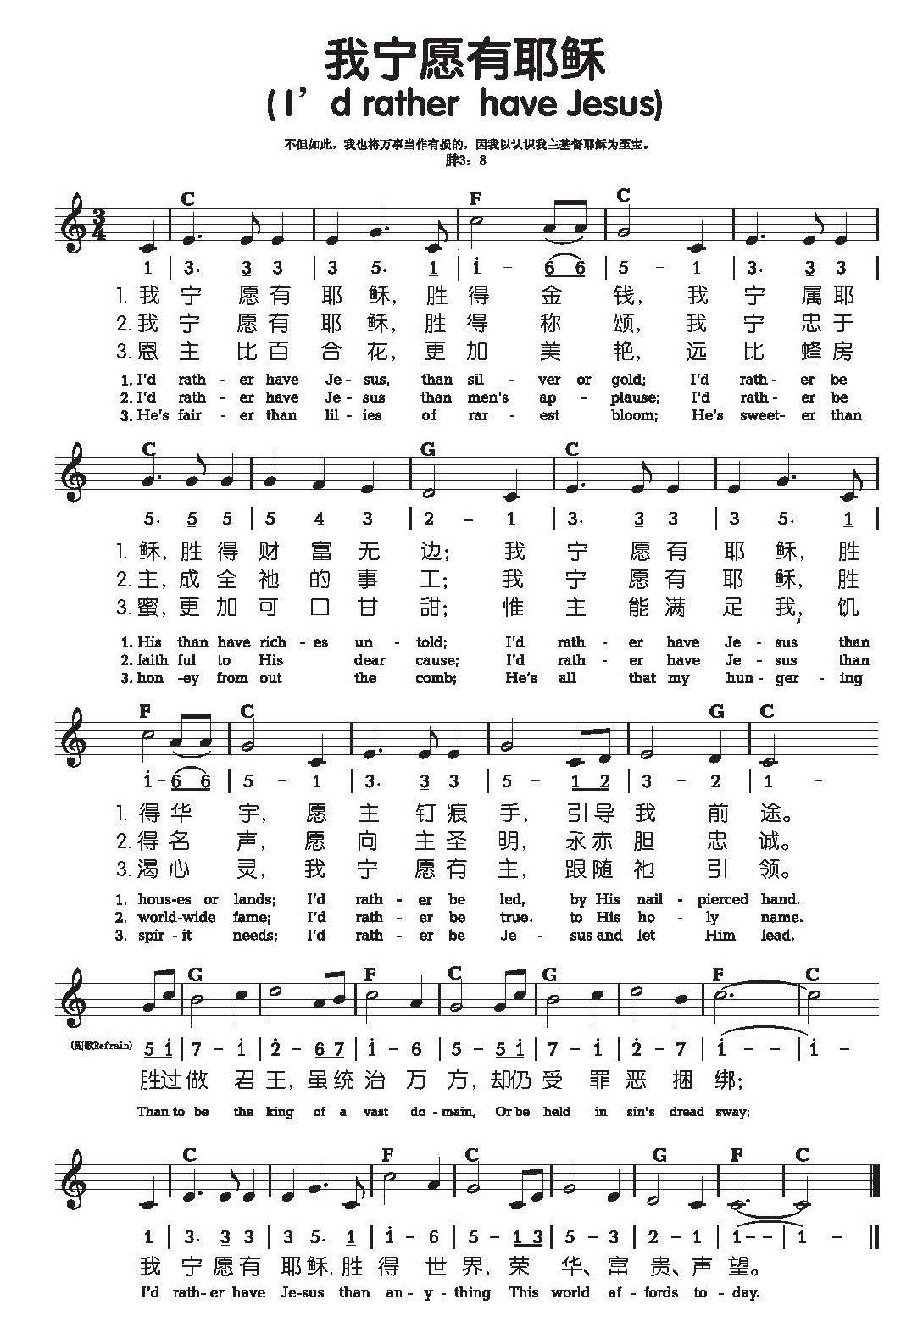

我宁愿有耶稣吉他谱(降D調)
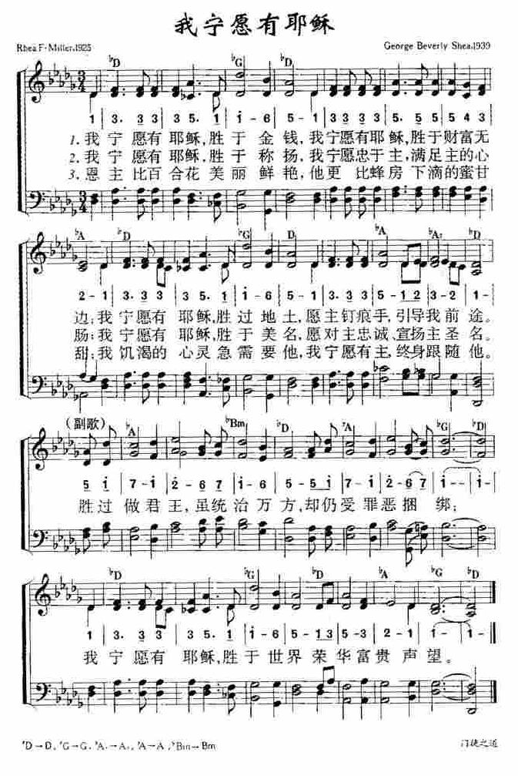

I'd Rather Have Jesus sheet music for Piano (D♭ tuning)
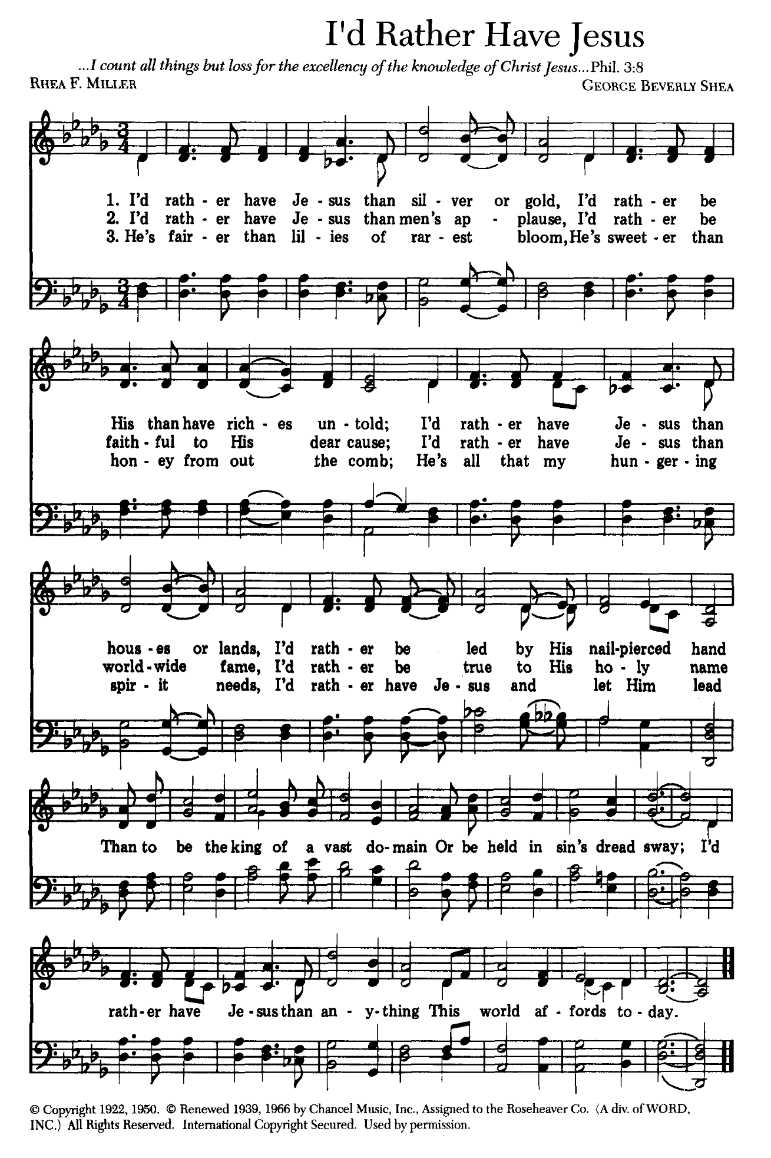

I’d Rather Have Jesus
Today’s hymn was penned in 1922 by Rhea F. (Ross) Miller and its most famous melody composed by George Beverly Shea in 1939.
Rhea F. (Ross) Miller
Rhea was born in 1894 in Brooktondale, New York to parents Martin and Bertha Ross. Rhea’s mother was a Christian but her father was an alcoholic who wanted nothing to do with church or religion. Bertha, however, faithfully prayed for her husband and he eventually accepted Christ and became a pastor.
The Miller family attended Martin’s church where their son Howard met Rhea, fell in love and married. The story goes that Rhea was walking through a field near her home in 1922 and began to reflect on her father’s testimony of being delivered from alcoholism, and how he would rather have Jesus than all the silver and gold. From those reflections she penned the words – one source indicates that she also composed music to accompany them — but the melody that would make the song known world-wide would be composed several years later.
George Beverly Shea
George Beverly Shea was born on February 1, 1909 in Winchester, Ontario, Canada to Adam Joseph and Maude Mary Theodora (Whitney) Shea. His father was a Wesleyan Methodist pastor, ministering in Canada until taking a pastorate in New York. Bev Shea, with his distinct baritone voice, first performed publicly as a member of the church choir.

这首相当感人的福音诗歌,作者是蜜勒夫人(Rhea F. Miller)于1925年所作, 这是美国教会近代年轻人最喜爱与流行的歌曲,许多人受到这首歌很大的影响及改变。
这首歌还发生了一段感人的真实故事:大约在五十多年前,那时候美国商业经济很不景气,在纽约到处都听说公司要裁员、减薪,因此失业率不断的增加。这时候有一位年轻人,他本来是保险公司的职员,却幸运的得到一个很不错的新工作,有很高的职位与待遇,就是在一家有名的广播电台,专门负责播放流行音乐。然而当他到教会敬拜唱诗歌之时,忽然圣灵的感动与提醒使他想到:我既然是一位基督徒,怎么可以放弃圣乐而去播放世俗的歌曲呢?此时,他正好看到这首"我宁可有耶稣"时,他作了一个非常不容易的决定,就是辞掉这份得来不易的工作,他愿意放弃了属世的欲望而宁可有耶稣。后来,有很多人听见了这个故事,不但深受感动而且真正改变了他们的生命。
第二次大战期间，英王乔治六世夫妇访问美国，受罗斯福总统款待。在晚宴中，邀请一位知名的印地安人基督徒，献唱以娱嘉宾。先唱过几首古典歌曲，接着唱“我宁愿有耶稣”。中间，他忽然问王后：“尊贵的女士，您有耶稣吗？”王后点头；并说：“英王陛下也信主。”那印地安基督徒继续唱副歌：
Than to be the king of a vast domain
Or be held in sin's dread sway;
I'd rather have Jesus than anything
This world affords to-day.
不愿作君王领域广大 却受罪权所管辖
我宁愿有耶稣胜得今世 任何富贵荣华
刚唱完，素来严重口吃的英王，大声宣告：“我也宁愿有耶稣！”

