Hymn

Praise Him! Praise Him!

風火網頁 Webpage: https://www.feng-huo.ch/
Date: February 1, 2019

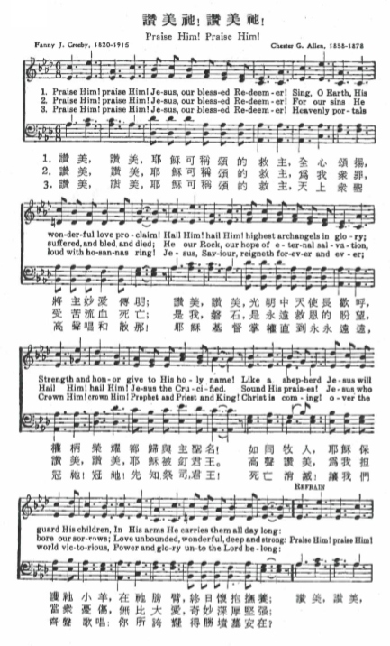
Praise Him! Praise Him! (Piano Sheet Music)

