Hymn

All For Jesus

Webpage: https://www.feng-huo.ch/
Date: February 16, 2018

All For Jesus – Sheet music for Piano (F Major)
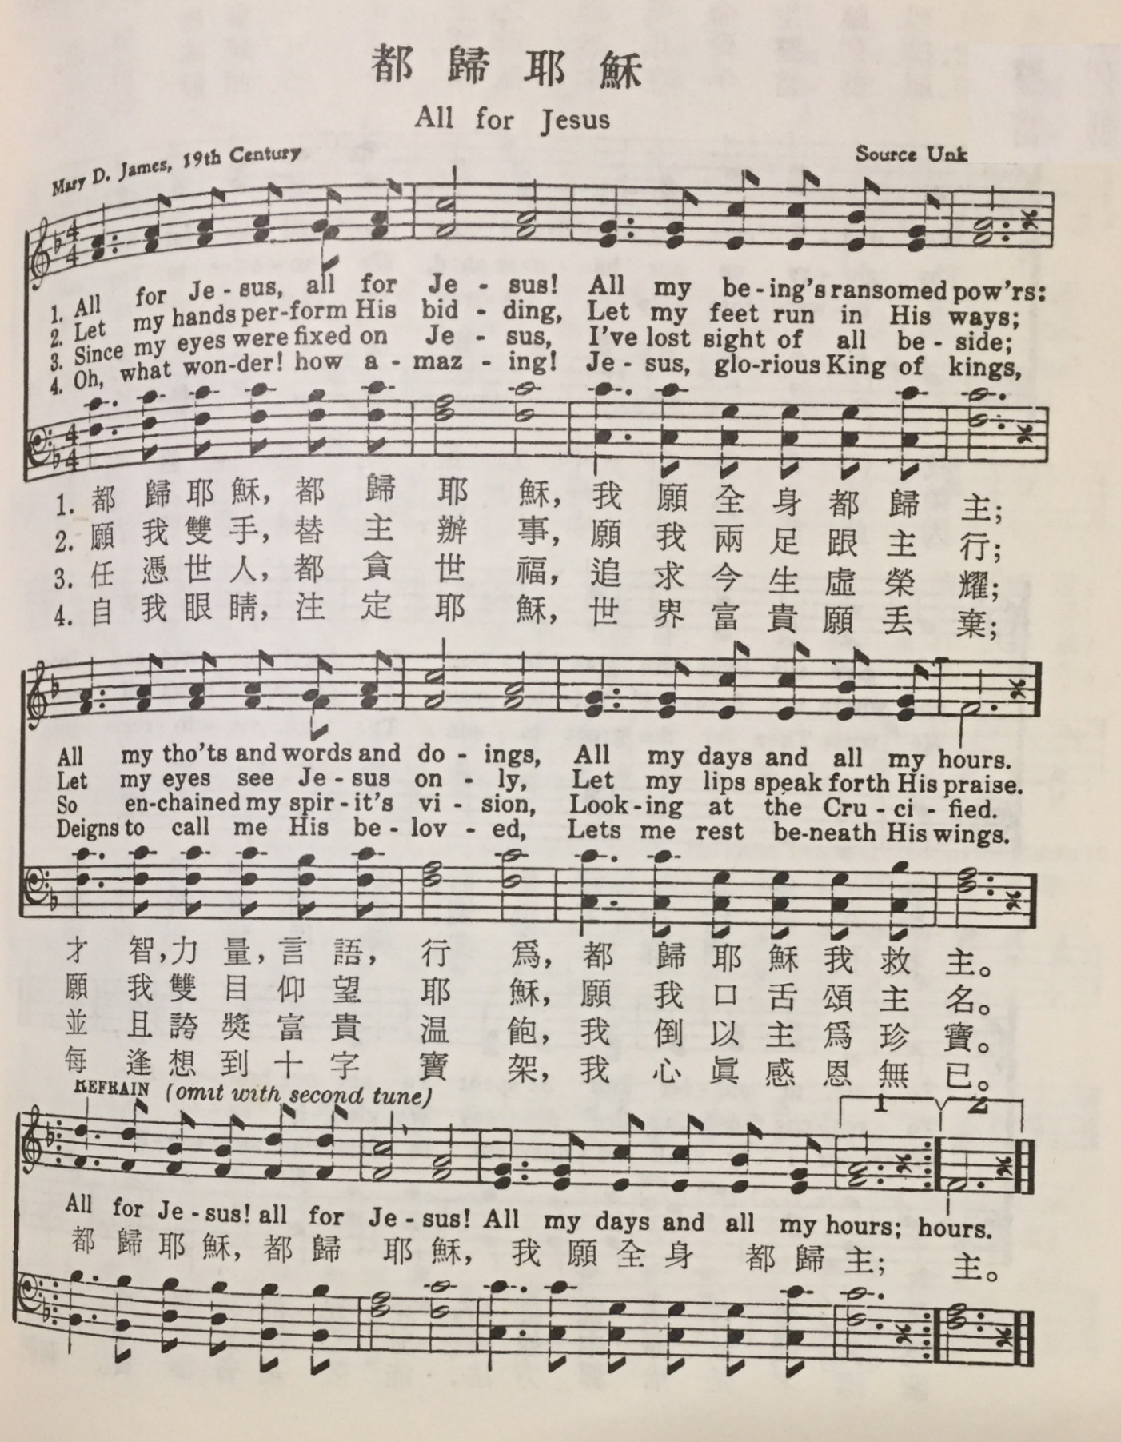

All For Jesus – Sheet music for Piano (Eb Major)
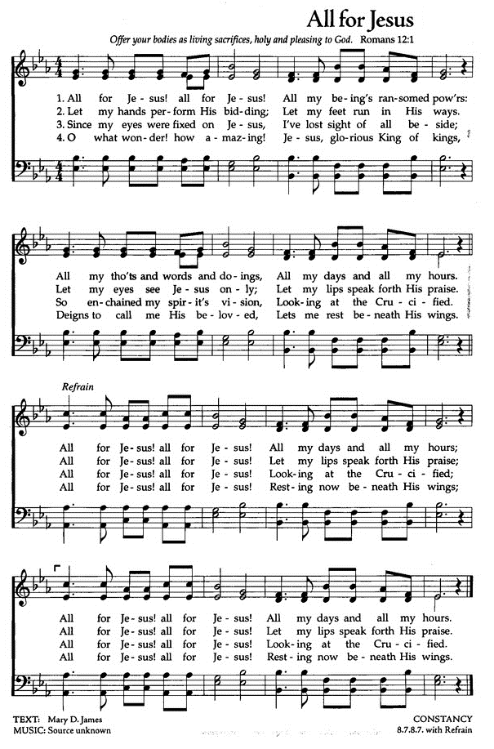

All For Jesus–Sheet music for Piano and Guitar (Eb Major)

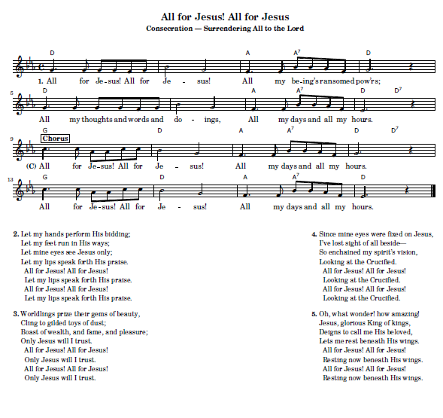

All For Jesus – Sheet music for Guitar and Text
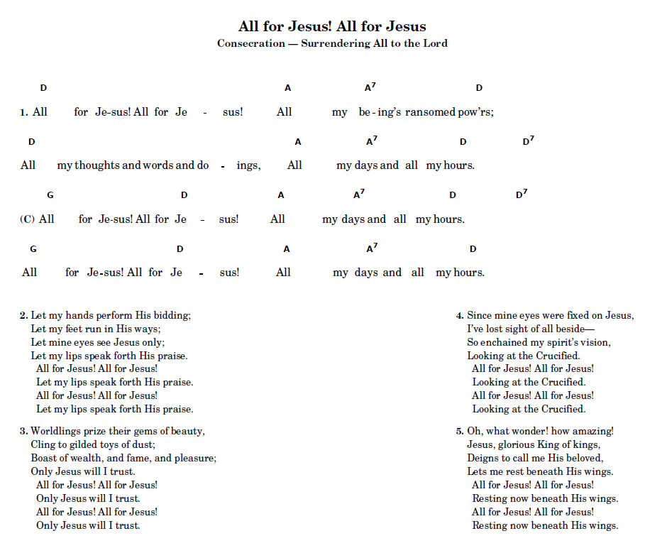

Mary Dagworthy Yard James 1810 - 1883
Resource: http://www.hymntime.com/tch/bio/j/a/m/james_md.htm
Born: August 10, 1810, Trenton, New Jersey.
Died: October 4, 1883, New York City.
Buried: Mercer Cemetery, Trenton, New Jersey.
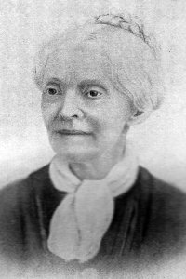

ALL FOR JESUS (Mary D. James)
A Biographical Sketch of, Mary D. James

Here was a life of full consecration and trust, continually maintained. It was the habit of her soul, as spontaneous as the involuntary action of lungs or heart, to give all to Christ and receive Him by faith in the fullness of His power.” This is the testimony of Rev. Joseph H. James, concerning his mother, Mary D. James, author of the well-know hymn, All For Jesus. From the moment of birth, August 7, 1810, at Trenton, N.J., her mother Priscilla Keen Yard had consecrated the little one to God. It was her specific prayer that her first daughter (after eight sons) might always choose “the better part” and appropriately named the infant Mary. Mother Yard spoke to young Mary daily about the Savior and did much to turn her desires toward Jesus.
Although Father Benjamin Yard was a Quaker and Mother a Baptist, it was in a Methodist revival meeting that Mary D. Yard experienced the new birth. One Sunday evening as they were preparing to attend the revival, Mother Yard encouraged her daughter to seek the Lord for salvation as many others had been doing. This admonition went right to Mary’s heart. Long before the invitation was given, she was ready to go forward, but Mary found no peace that evening. Instead, she spent an almost sleepless night in agony of soul. Encouraged by her mother, the young seeker continued her supplications until Tuesday, February 18, 1821. At the prayer meeting Mary broke through. The glorious prize which she had sought was won. She had the assurance that her sins were forgiven. But several days later, Mary overheard her grandmother ridiculing the salvation of her ten-year-old grandchild. She was thrown into confusion until she fell on her knees in her room and poured out her heart to the Lord once more. There the Lord spoke to her in such a way that all doubts were swept away forever. A little while later, she again overheard her grandmother say, “After all, I do think that child has been converted. I have been watching her closely and see a great change in her spirit and life.” The experience set a pattern for all her life. Her problems were always brought straight to the Lord with wonderful results. From the age of ten, Mary began a life of prayer which increased to “prayer without ceasing.”
At school, Mary let her light shine for Jesus. She spoke to her young friends about the Savior. One day, Mary was allowed to be “monitor” while the teacher was out of the room. During this time, she spoke to the class of girls about their sins. At first, they jeered and mocked. But when the teacher returned, all the girls were on their knees, many of them crying to God for mercy. Several were born again that day.
On another occasion, Mary stayed behind at recess time to write a note to an unsaved friend, urging her to “taste the joys of salvation.” The curious teacher intercepted the note. As he read the earnest plea, tears filled his eyes, and he asked Mary to teach him the way of salvation. Although she was timid and shy, she lifted her heart in prayer and told him exactly how she found Jesus. Before long, the teacher was soundly converted. He became a leader in a Presbyterian church in Trenton, New Jersey. Teacher and student were life-long friends.
But, as wonderful as these experiences were, Mary had a great hunger for more of Jesus. “I cannot rest till I am wholly sanctified,” she wrote in her diary. Several days after this entry, Mary was asked to lead in prayer at the weekly prayer meeting. She hesitated because of her age (12), then began in faltering tones. Hardly had she uttered a sentence or two when the Holy Spirit came upon her and seemed to lift her into the heaven lies. For more than an hour, she spoke to Jesus as face to face, unconscious of earthly things. She recorded the wonderful experience in her diary, “He had heard and answered my prayers, and this night my soul rejoices in that perfect love which cast out fear . . . I am at this moment a witness that His precious blood cleans from all sin.” “From that hour,” Mary later testified, “my peace has been as a river. I have no other will than to do the will of God, no other desire but to work and speak and think for Him . . . . To be burned at the stake would be infinitely preferable to an act that would offend my Lord to whom I have consecrated all my soul and body’s powers; yes, all I know, and all I feel; all I have, and all I am.” Some time later at a camp meeting the Lord added yet another blessing to the young whole-hearted convert. There, at an altar service, she was imbued with “power from on high” for the service of the King. Over and over again, throughout all her 73 years, God anointed His vessel, always adding to her knowledge of Jesus and her usefulness in serving Him.
At the age of thirteen, Mary taught her first Sunday school class. She was not content to see them on Sunday only. She visited them individually in their homes and brought them all to her own home for a prayer meeting regularly. The class doubled in size in a very short time. Almost every one became an active Christian worker in some capacity. Soon Mary was asked to be the assistant superintendent of the Sunday school. So active and so successful did the young worker become that many wondered what the secret of her success was. Undoubtedly it was founded upon two principles: first, her faithful personal devotions. Not only did she have several fixed times of devotion on a daily basis, but also she had great delight, when duties would permit, to spend protracted times in prayer. Late in life, Mary remarked, “Here is the secret of being kept by the power of God in the slippery paths of youth.”This love for personal devotion increased through the years. Also, Mary was very diligent to make good use of her time. She determined that no hours should be “wasted in useless adorning, worldly amusements, or formal visiting.” Mary souls were won to the Lord by this wise combination of principles.
As Mary matured, several earnest Christian young men became interested in her. Each time that she became aware of these attentions, she immediately brought the matter before the Lord. Each time, the Lord led her to discourage their attention. In this way, several naturally desirable “attachments” were nipped in the bud because she believed they were not in the will of God. When Henry B. James became a suitor, however, Mary, after much prayer, accepted his attentions. It was their customer from the very beginning to spend part of the time they were together in reading the Scriptures and prayer. While their love for each other grew, each partner was diligent that love for the Savior should not diminish. A young Christian lady watched Mary closely at this time. She wondered if it were possible for a courtship to be carried on by a devoted Christian without spiritual loss. The testimony of all concerned was that the young couple so conducted themselves that the dangers of spiritual loss were avoided. “It cannot be that an institution in the order of God, and sanctioned by the presence of Jesus during His sojourn on earth, can be incompatible with purity of heart and union and communion with God.” Mary testified to the curious friend that she felt no spiritual loss! In the summer of 1834 Mary D. Yard became Mrs. Henry B James. The young couple moved to Mount Holly, New Jersey. Quietly, Mary took her place in the Methodist church at mount Holly. Four children blessed the home. Although Mrs. James was necessarily occupied with domestic duties, she found time to work for her Savior. At one point, however, the young mother became so engrossed in sewing for her children that she neglected her writing. This had become a very blessed part of her ministry. Mary articles for children and adults had been published simply under the by-line, “Mary”. Later she allowed her full name, Mary D. James, to be used. Now the wife of Dr. W.C. Palmer, editor of “Guide to Holiness,” In almost every letter, the theme was Christ. Mary poems were included in her works. Two of these poems have endured the test of time and continue in use as hymns of the church today. Companionship With Jesus with music by W. J. Kirkpatrick is one. A scripture reference next to each line was recorded by Mrs. Col. Lowe of Xenia, Ohio, to illustrate the scriptural content of this hymn. The other well known hymn is “All For Jesus,” composed in 1871. This beautiful consecration hymn is not only her best remembered work, but it was actually her life motto and the emphasis of her ministry.
Short before departing this life, Mary D. James wrote a New Year’s letter, January 1, 1883, to a young friend, who taught a class of young people: “I think, of all my seventy-two years, this has been the happiest. Truly, my path is growing brighter as I go onward to my heavenly home.
“My heart exults in grateful praise to Him who in life’s early morning led me to devote my whole being to Him. It has been such a delightful service! Could I live a thousand years longer on earth, I would so gladly devote all my powers to the same hallowed service that has engaged my life for nearly sixty-two years. I have found it so sweet to live for Jesus. Tell this to your dear class of young people as my testimony, that IT PAYS WELL TO SERVE GOD. What a mistake people make in thinking they must go to the world for pleasure and seek in its vain amusements and follies for happiness. You and I know from our own experience that in spiritual things, in the work that Jesus has given us to do and in the approving smiles of our God, there is solid, pure, and perpetual enjoyment. “How I do long to see our young Christians wholly consecrated to God! Dear sister, you may have many years yet to live. Let it be your constant effort to influence the young to devote themselves without reserve to God. . . . When, at the missionary meetings, prayer was asked that God would send more young ladies for foreign work, I felt like saying, ‘In order to do this, let us older Christians try more earnestly to influence our young ladies to be all consecrated. Then they will be ready to enter upon missionary fields or any other work for Christ.’ “It has been my constant effort all these years to bring others to entire consecration to His blessed service to whom I have delighted to give my heart, my life, my all. O how this great matter of entire devotion to God looms up before me now as I am nearing the end of my life’s journey! . . . Every consecrated one may influence others to a life of devotion. And each one thus brought nearer to Christ may bring more, and thus as the number multiplies through the years, what results of incalculable good! It is beyond the computation of our finite power, and will task our immortal capacities through all eternity to make the grand estimate. In view of all this, can we be too earnest, too self-sacrificing, or too persistent in our efforts to bring souls to Jesus and to build up and strengthen Christians in a life of holiness?”
On October 4, 1883, Mrs. Mary D. James went to be with the Lord, having lived 73 years, including 63 years All For Jesus!

